CMS 2021

A Project Report on…

CMS

Developed By: Shingala Amit
Submitted To…
Geetanjali College Of Computer Science and Commerce Saurashtra University Rajkot
[2021-22]
Guide Name : Prof. Meghna Bhatt

PREFACE
CMS
2021

we would also like to thank my Faculty Guide Prof. Meghna Bhatt , Geetanjali College Of Computer Science and Commerce(BBA), Rajkot for his valuable guidance and continual encouragement throughout the major project. we are heartily thankful to him for his time to time suggestions and the clarity of the concepts of the topic that helped me a lot during this project.

we are also thankful to Prof. Meghna Bhatt for her continual kind words of encouragement and motivation throughout the Major Project.

we are thankful to all our faculty members of Department B.C.A.,Geetanjali College Of Computer Science and Commerce(BBA), Rajkot for their special attention and suggestions towards the project work.

The blessings of God and our Family members make the way for completion of Major Project. we are very much grateful to them.

The friends, who always bear and motivate us throughout this course, we are thankful to them.

ABSTRACT
CMS
2021

CMS is Correspondence Management System. It’s use for Company, organization, etc. It’s use mainly for Internal Employee is Conversation. In any Company, Organization has record for employee’s conversation. Conversation must be officially.

INDEX
CMS
2021

SR.NO | SUBJECT | PAGE NO.
1 | Project Profile | 4
2 | Project Summary | 5
3 | Project Management  - System Requirement Analysis  - Feasibility study  - System Design  - Code Generation  - Testing  - Implementation  - Maintenance | 7
4 | Project Plan  - Milestones  - Deliverables  - Role and Responsibility | 14
5 | System Requirements (Hardware and Software) | 16
6 | About ASP.NET | 17
7 | About Sql server | 18
8 | Three Tier architecture  - Application Layer  - Data Access Layer  - Business Access Layer | 19
9 | E-R diagram | 22
10 | Use Case Diagram | 24
11 | Data Flow Diagram  - Context Level (0) Diagram  - First Level Diagram  - Second Level Diagram | 26
12 | Data Dictionary | 29
13 | Snap Shots | 32

Ch:-1
CMS
2021

PROJECT PROFILE

Name of the Project | CMS
Developed for | Saurashtra university
Front-End Tools | Asp.Net with C# Language(Microsoft Visual Studio 2008)
Back-End Tools | SQL Server 2005
Other Tools | Adobe Photoshop 7.0,Paint Brush
Submitted to | Geetanjali Group Of Colleges
Internal Project Guide | Prof. Meghna Bhatt
Developed by | Shingala Amit
Developed At | Geetanjali Group Of Colleges

Ch:-2
CMS
2021

PROJECT SUMMARY

- CMS
[Summary:]
- CMS is Correspondence Management System.
- It’s use for Company, organization, etc.
- It’s use mainly for Internal Employee is Conversation.
- In any Company, Organization has record for employee’s conversation.
- Conversation must be officially.

PURPOSE:
- In the past employee want to conversation with any other departments or any other employee than first the employee can go to met the employee and conversation. But this type of conversation is not a stored as record or not officially.

- Correspondence Management System (CMS) is a Web Application for any Company, any Organization internal conversation.

- Conversation is officially for the any company or any Organization.

- In this Web Application Employee can conversation through this web application and conversation is stored as a record.

- Employees can conversation with any other department’s employee and his department’s employee.

CMS 2021

SCOPE:
- Is any employee use our facility so first being the register of our site.
- After any registration any Employee can send message and officially conversation through this Web Application.
- Employee can manage his Profile.

Ch:-3
CMS
2021

PROJECT MANAGEMENT

  - System Requirement Analysis

  - Feasibility study
  - System Design
  - Code Generation
  - Testing
  - Implementation

  - Maintenance

Project Development Approach
› This strategy is often referred to as software process model and software engineering paradigm.

› To solve actual problems in an industry setting, a software development strategy must be incorporated that encompasses the process, methods and tools for software engineering.

› Here, This web-project development on the base of SDLC (Software Development Life Cycle).

› SDLC have a different step of development of web-project or any type of application.

› The project develops in the 3-tier architecture of asp.net framework.

CMS 2021

➲ Following the SDLC steps are use in the application development:

- System Requirement Analysis.
- Feasibility Study.
- System Design.
- Code Generation.
- Testing.
- Implementation.
- Maintenance.

    - System Requirement Analysis :

› In this phase, the development team visits the need for possible software requirement in micro-depth for develop the system.

› The basic clearance of the application they informed by the investigation team of system requirement analysis.

› Understanding fully what a project will deliver is critical to its success.

› Steps :

      - Don't assume you know what the customer wants, ask.

      - Define and agree the scope of the project.

      - Create a clear, concise and thorough requirements document and share it with the customer.

CMS 2021

      - Confirm your understanding of the requirements with the customer.

      - Create a prototype if necessary to confirm or refine the
customer’s requirements.

    - Feasibility Study.

› Feasibility means the analysis team’s report first study and that after the decision for create this application.

› This team internally show the company possibility of develops this type of application.

› Here, Tools & Technology, Economically, Government Rules & regulation are considered

      - The human and economic factor :

› Economical analysis is the most frequently used technique for evaluating the effectives of a proposed. This is known as the cost/benefit analysis.

› The procedure is to determine the benefit and savings that are expected from a propose system and compare them with the cost. If benefit outweighs cost a decision is taken to design and implement the system otherwise father justification or alternative in the proposed system will have to be made if it is to have a change of begin approved.

      - The possible solutions to the problems :

› At any time company provide the solution between the deals time duration. Companygives complete satisfaction for problems of the customer.

      - Government Rules and Regulation:

CMS 2021

› Here, company developed web and application on base of government rules and regulation.

a) Finally, the development depends on study team yes or no and customer rapidly creates this application with you company.

    - System Design.

› This phase works on the creation of the first pre-model of the whole system.

› In terms of the end user/server technology, the number of tiers needed for the package architecture, the database design, the data structure design etc are all defined in this phase.

› Preliminary or General Design
In the preliminary design, the features of the new system are specified. It also known as General Design

› Structured or Detailed Design
Structure design is a blue print of a computer system. It also known as Detailed Design

› There are several tools and techniques used for design the system.
➲ Use Case Diagram
➲ E-R diagram
➲ Data flow diagram (DFD)
➲ Data dictionary

    - Code Generation.

› The design must be converting into a machine readable form.

› Programming tools like Compilers, Interpreters, and Debuggers are used to generate the code. Different high level programming languages like C, C++, Pascal, Java, ASP.NET and VB.NET are used for coding.

CMS 2021

› If design is performed in detailed manner, code generation can be accomplished without much complication.

› After creating the System Design It required to implement into the computer understandable language so we can provide the coding to the designed system.
    - Testing.

› Testing provide the facility of the checking whole developed system by the company.

› The various type of testing is accrues, unit testing, system testing, security testing like more.

➲ Unit Testing :

› Using the component level design description as a guide, important control paths are tested to uncover errors within the boundary of the module.

› First, the module interface is tested to ensure that information properly flows into and out of the program unit under test.

› Then local data structures are examined to ensure that data stored temporarily maintains its integrity during all steps in an algorithm’s execution.

› All independent paths through the control structure are exercised to ensure that all statements in a module have been executed at least once.

› Unit testing is normally considered as adjust to the coding step.

› A review of design information provides guidance for establishing test cases that are likely to uncover errors in each of the categories.

- System Testing :

CMS 2021

› System testing is actually a series of different tests whose primary purpose is to fully exercise the cross-based system.

› Although each test has a different purpose, all works to verify that system elements have been properly integrated and perform allocated functions.

› It has mainly three type of testing Units.
- Recovery Testing
- Security Testing
- Performance Testing

- Recovery Testing :

› Recovery testing is a system test that forces the s/w to fail in a variety of ways and verifies that recovery is properly performed.

› If recovery is automatic, re-initialization, checkpoint mechanism, data recovery, and restart are evaluated for correctness.

- Security Testing :

› Security testing verifies that protection mechanism built into a system will, in fact, protect it from improper penetration.

› During security testing, the tester plays role of the individuals who desires to penetrate the system.

- Performance Testing :

› Performance testing is design to test the run time performance of software within the context of an integrated system.

› Performance testing occurs throughout all steps in the testing process.

CMS 2021

› Performance tests are often coupled with stress testing and uses required both hardware and software instrumentation.

- Implementation.

› Implementation is the stage of a project during which theory is turned into practice. The major steps involved in this phase are:

› Acquisition and Installation of Hardware and Software

  - In this step the company installs the application on user (client) system or hosting on the web server.

› User Training

  - The company gives the facility on contract with client for operate this application as well as freeware.

- Maintenance.

› The upper all functionality of the application like testing, web hosting, user training, change any time in its client application.

› Here, company also provides the facility of the anytime error or bug solution or problems of application develop by them for his client.

› All of the functionality provides by company with deal time duration or deal times over the company provide the paid service for them.

Ch:-4

PROJECT PLAN
CMS
2021

  - Milestones
  - Deliverables
  - Role and Responsibility

› A plan is drawn up at the start of the project, should be used as the driver of the project.

› The project planning consists of:

    - Selection of suitable software development process model which I have selected Interactive Water Fall Model.
    - Risk Management, which involves the risk identification and risk assessments.
    - Project Scheduling, which involves the tasks and duration required for performing tasks. This is described by task representation and the Timeline chart representation.
    - Cost and Effort estimation is which involves estimation of cost as well as effort applied by the developers.

› Management needs information. As software is intangible, this information can only be provided as a document that describes the state of the software being developed.

› Without this information, it is impossible to judge progress and cost estimates and schedules cannot be updated.

- Milestones

CMS 2021

› Milestone is an end-point of the software process activity.

› At each milestone there should be formal output, such as report, that can be represented to the management.

› Milestone report need not be large document; they are the short report of achievements in software project activity.

› Milestone represents the end of the distinct, logical stage in the project.

- Deliverables

› Deliverable is a project report that is delivered to customer.

› Deliverables are delivered to the customer at the end of the same major project phase such as specification, design, etc.

› Deliverables are usually milestones. Milestones may be internal project results that are used by the project manager to check progress but which are not delivered to the customer.

- Role and Responsibility

› Thus administrator is the person who is responsible for whole management of the organization.

› In this web application the ADMIN module functionality enter new product, category, sub-category, discount and main admin create other admin usage this application.

› And the Admin can manage the Products,category, Sub-category, rights to login,discount, offers and advertisement.

Ch:-5
CMS
2021

SYSTEM REQUIREMENT

› At operator’s side, a web application is explored through web browsers like Microsoft Internet Explorer, Mozilla Firefox etc.

› The following are the minimum system requirements: MINIMUM SERVER HARDWARE REQUIREMENTS:
- Intel Core2Duo processor or higher
- 10 GB RAM
- Disk space as per growing database and size of web application

MINIMUM SERVER & SOFTWARE REQUIREMENTS:

- Microsoft Visual Studio 2008 or newer version
- Microsoft SQL Server 2005
- IIS (Internet Information Services) Server

MINIMUM CLIENT SOFTWARE REQUIREMENTS:

- Web browsers (Internet Explorer 7.0 or newer, Mozilla Firefox3.5 or newer)
- Active internet connection

› To access the website at client’s side, they only need an Internet connection, web browser and some additional features installed such as Macromedia Flash Player, some plug-ins etc. Once minimum requirements are met, rest depends on Internet connection speed.

Ch:-6
CMS
2021

 ABOUT ASP.NET

  - The project is designed in ASP.NET as front-end tools, which provides excellent development and graphics user interface. Asp.Net has facility to connect various database software like Oracle, Ms-access etc…
  - ASP .NET has better language support, a large set of new controls and XML based components, and better user authentication. ASP .NET provides increased performance by running compiled code.
  - Better language support
  - Programmable controls
  - User authentication, with accounts and roles
  - Higher scalability
  - Increased performance - Compiled code
  - Easier configuration and deployment
  - Not fully ASP compatible
Language Support:-
  - ASP.NET uses the new ADO .NET.
  - ASP.NET supports full Visual Basic.
  - ASP.NET supports JScript as before.

Ch:-7
CMS
2021

ABOUT SQL SERVER
SQL Server 2005 introduced a radical upgrade to SQL Server 2000’s Data Transformation Services (DTS). The differences were so great that a new name was given to the tool SQL Server Integration Services (SSIS). Whether or not we are a heavy user of DTS; SSIS can seem overwhelming when we first try to create a package. In the business world, everything is about being "better, faster and cheaper" than the Competition -- and SQL Server 2005 offers many new features to save energy, time and money. SQL Server 2005 is a powerful tool for turning our enterprise data into a completive advantage.

Feature of SQL Server 2005:-
  - Database Mirroring
  - Fast recovery
  - Standard base information access
  - SQL server management studio
  - Data partitioning
  - Internet Integration.
  - Scalability and Availability.
  - Data warehousing

Advantage of SQL Server:-

Multiple views of Data.(The database can be constructed so that each user sees data for only their departments or sales region. SQL views used to enhance the security of a database).
Complete database Language.(SQL provides a Complete, Consistent Language for creating a database, managing its security, updating its content, retrieving data and sharing data among many concurrent users).
Client/Server Architecture (SQL server behaves as link between “front-end and back-end”).

CMS 2021

CH:-8

WORKING WITH 3-TIER ARCHITECTURE

  - Application Layer
  - Data Access Layer

  - Business Access Layer

I-MART isdeveloped on the base of 3-tier architecture.3-tier architecture is the best architecture for development of any web or application because they provide a code reusability or code redundancy.

Here, its three layers individually use the four time one by one sequentially.
    - Application Layer
    - Data Access Layer
    - Business Access Layer

- Application Layer:
  - Application layer have a two parts,
    - Design
    - Code

CMS 2021

  - First use application layer in web or application development. In this layer first use the design portion because the overall project design complete that after the code generate by developer easily. The code portion uses the after use DAL or BAL.

- Data Access Layer:
- Data Access Layer sorts the code use in application. They have a three parts,
  - Connection
  - Command
  - Parameter

- Connection

  - Those after Create_Connection.csfile open this connection and close this connection.

Command

  - In Create_Command.cs file create an Executable or Non- executable command depend on the query or stored- procedures.

Parameter

  - Create_Parameter.cs file create a various type of data-type conversion by the developer.

- Business Access Layer:

CMS 2021

  - The all parts perform the Insert, Update, Delete, Select and Display code generate by the developer team.

  - Delete, Update, Insert action is known as Non-Executable commands and Select or Display action is also known as Executable command because they provide the output of executing command.
  - Entire projects’ three layers complete that after the Application layer’ code portion perform its action.

  - Here, connection, command, parameter not defined in entire application code but they divide in individual code file and use at a time in other file.

  - The code reduces main purpose of 3-tier architecture.

  - Application or web executing result so fast then compares the one tier architecture or 2-tier architecture.

CH:-9

E-R DIAGRAM
CMS
2021

Email id
Admin id

Admin Login

Admin name Password

Departname Depart Status

Depart id
Contact No

Emp id Emp name
Department

Desg id Desg name

Address

Designation
Employee

Desg Status

Department Designation

Gender

Photo Status

CMS 2021

M id Emp name Emp Depart Emp Desg

Message emp id

Sender depat

Depart id Desg id
Message

Sender desg

Sender status

Del status

M id Emp name Emp Depart Emp Desg

Message
Message Replay
Sender depat

C id
emp id

Depart id Desg id C Name

Del status

Sender desg

Replay

Sender status

O id Emp name Emp depart
Emp desg

Type of Conversation

Con status
Off Conv
Status

Message

Emp id

Desg id

Depart id

depart id Sender id
desg id



CH:-10
CMS
2021

USE CASE DIAGRAM

Admin

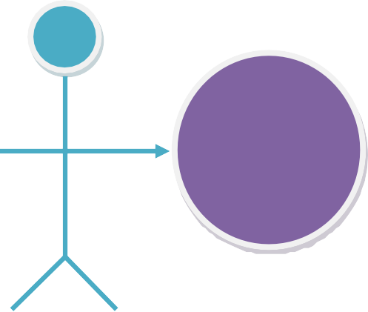
Add, Edit, Display,
Delete,
Employee
Admin

CMS 2021

Employee

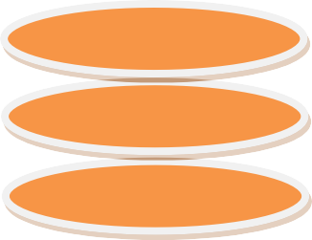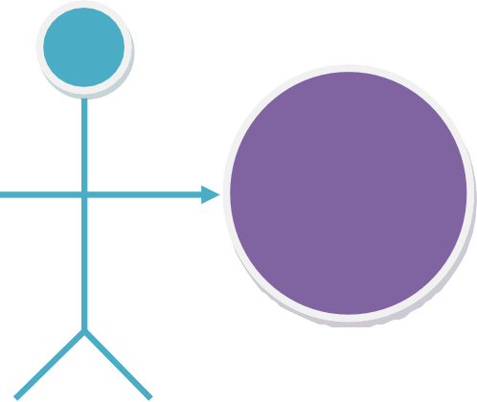
Add, Edit, Display,
Delete
Sned Mess

Replay mess
conv
Employe

CH:-11
CMS
2021

DATA FLOW DIAGRAM

  - Context Level (0) Diagram
  - First Level Diagram

  - Second Level Diagram

Respons
Request
CMS
Request
Respons

Employee

Admin

CMS 2021

DFD 1 Level
Admin

Admin
Response
Employee
Reques
client_detail

CMS 2021

Employee

Send Message
Emp
Replay Message
Official Conver
Off_conv
Replay Message
Message

CMS 2021

CH:-12

DATA MODELING

- Data Dictionary :

    - CMS_final_db:
Admin:-

- Admin Login :-

admin_id | int
admin_name | varchar(30)
password | varchar(30)

- Department :-

dipartment_id | int
dipartment_name | varchar(30)
Status | int

- Designation

designation_id | int
designation_name | varchar(30)
department_id | int
Status | int

CMS 2021

- Employee

emp_id | int
Fname | varchar(30)
lname | varchar(30)
gender | char(1)
emp_d_o_b | datetime
address | varchar(MAX)
city | varchar(30)
email | varchar(30)
designation_id | int
department_id | int
photo | varchar(MAX)
joining_date | datetime
status | int
password | varchar(20)

- Message

msg_id | int
emp_name | varchar(30)
designation_name | varchar(30)
dipartment_id | int
designation_id | int
emp_id | int
message | varchar(MAX)
sender_dipart | int
sender_desg | int
sender_id | int
status_del | int

CMS 2021

- Document

doc_id | int
emp_name | varchar(30)
designation_name | varchar(30)
dipartment_id | int
designation_id | int
emp_id | int
doc1 | varchar(MAX)
doc2 | varchar(MAX)
doc3 | varchar(MAX)
doc4 | varchar(MAX)
sender_dipart | int
sender_desg | int
sender_id | int

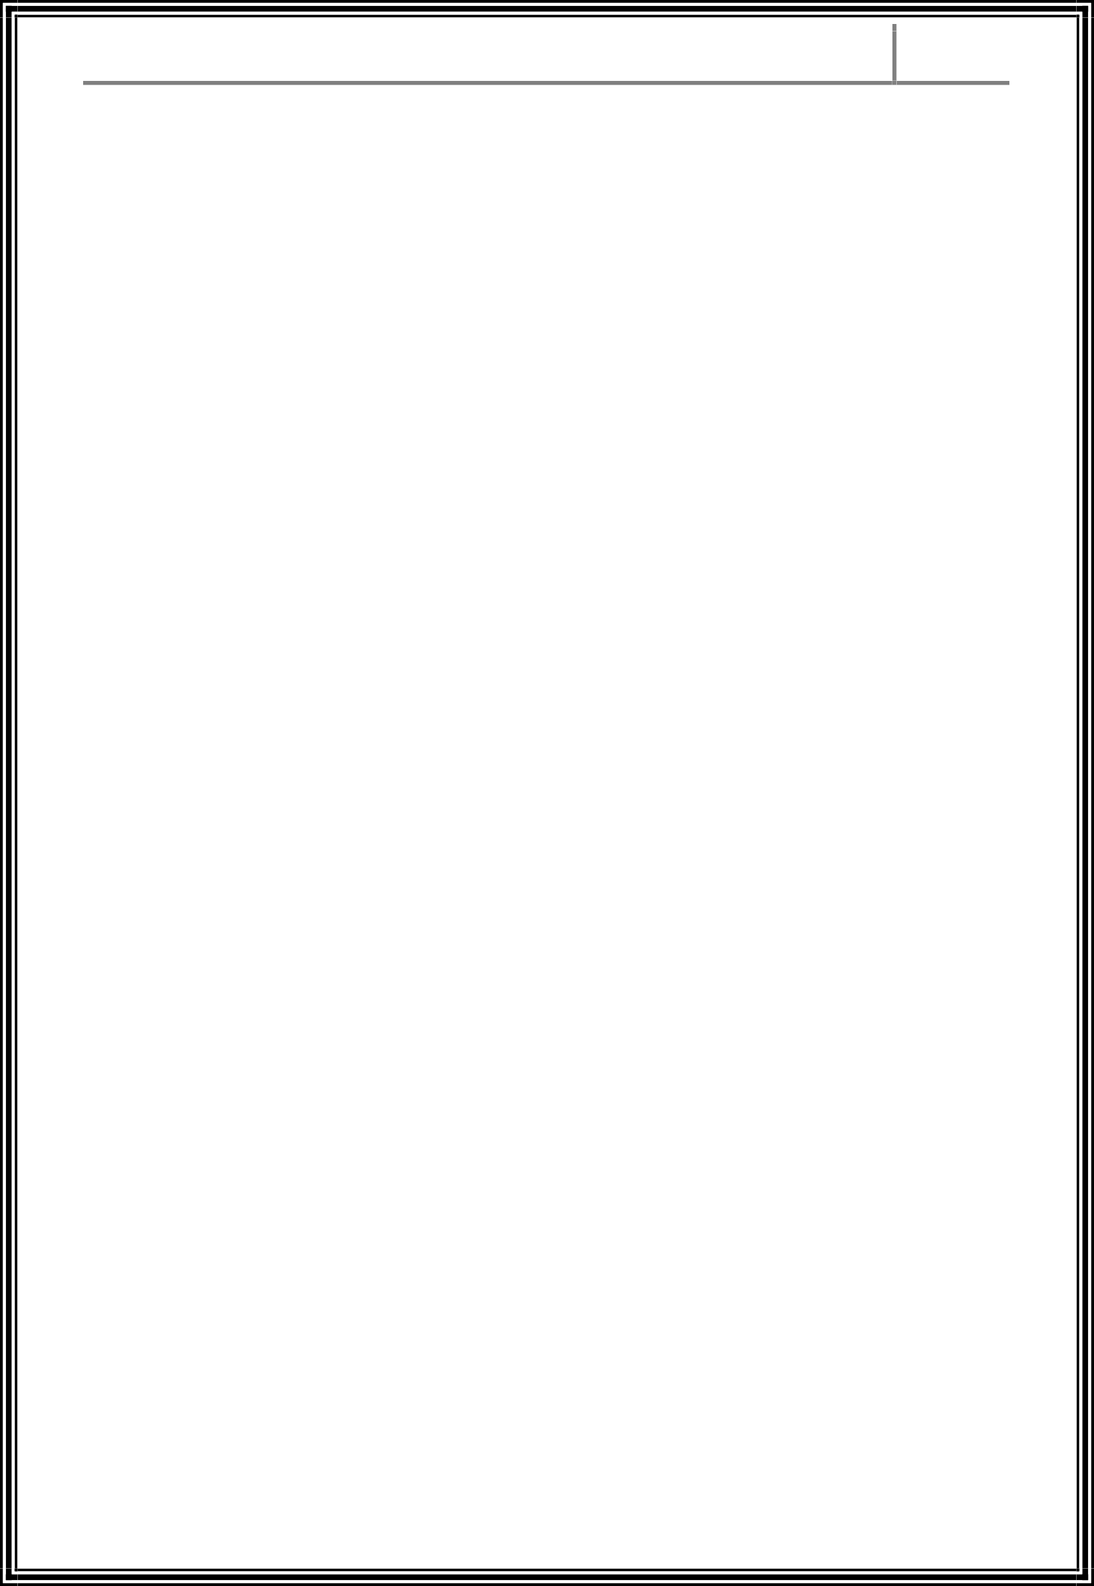

CH:-13
CMS
2021

CMS 2021

MODULE
ADMIN
HOME PAGE:

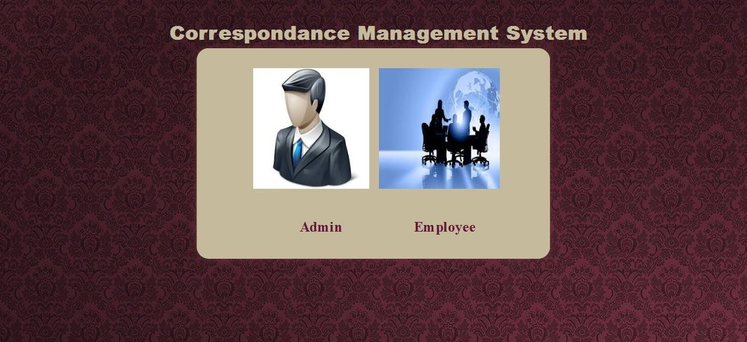

This page is home of cms

CMS 2021

VIEW DEPARTMENT:

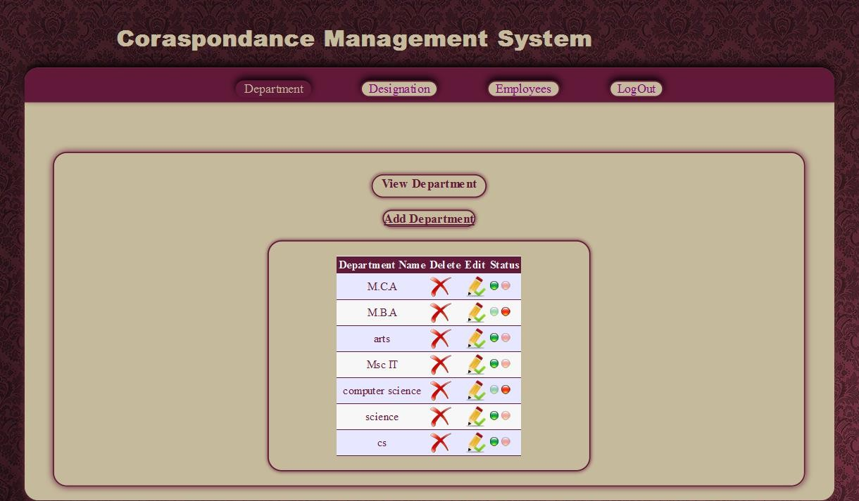

From this page you can see department details

CMS 2021

ADD DEPARTMENT:

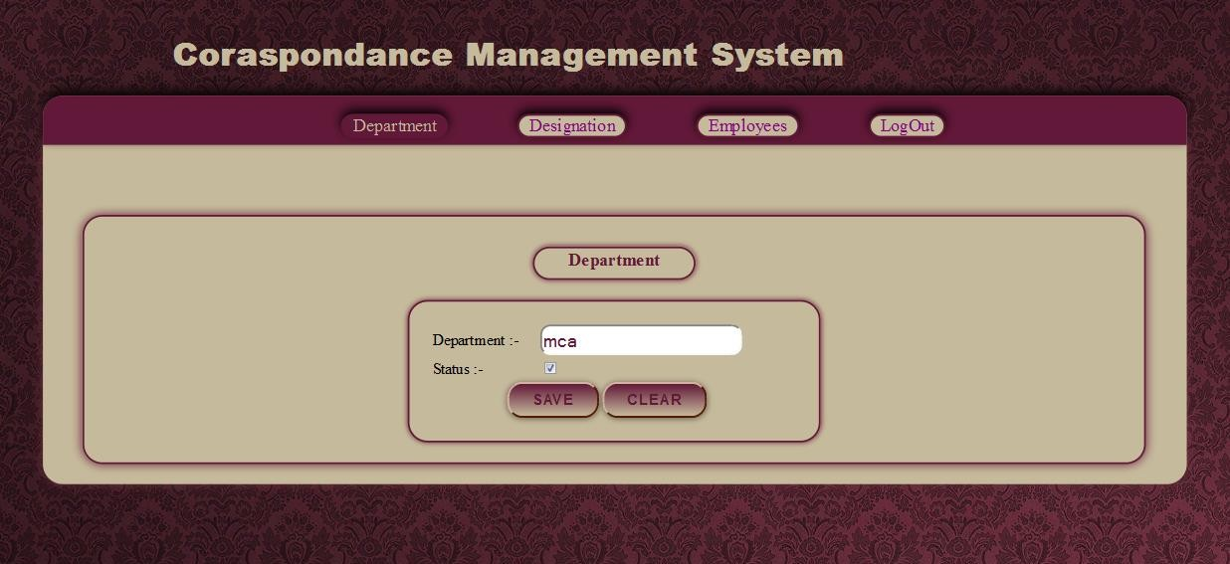

This page is used for add department

CMS 2021

VIEW DESIGNATION:

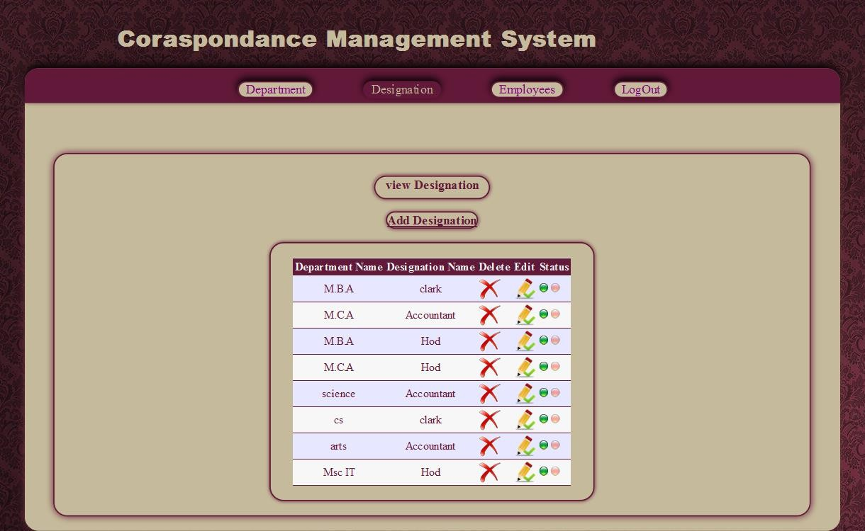

This page is used for show designation

CMS 2021

ADD DESIGNATION:

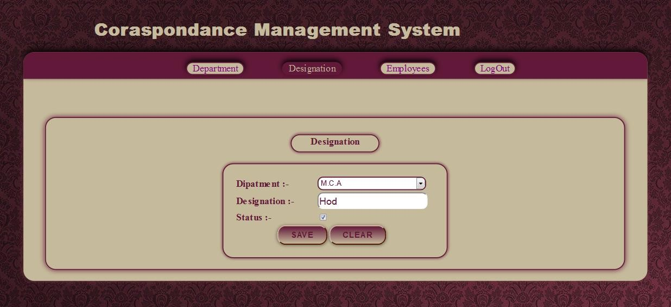

This page is used for add designation

CMS 2021

VIEW EMPLOYEE:

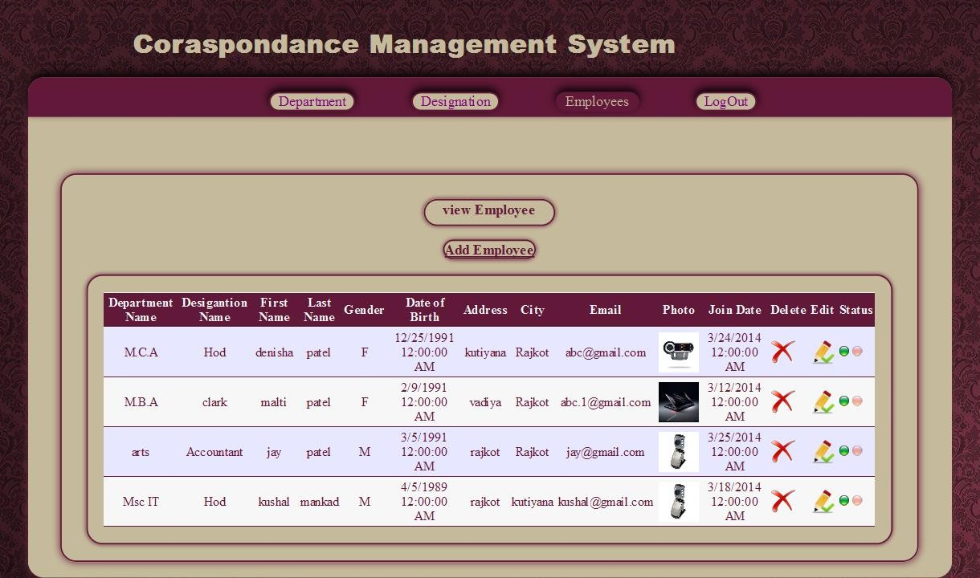

This page is used for show Employee details

CMS 2021

ADD EMPLOYEE:

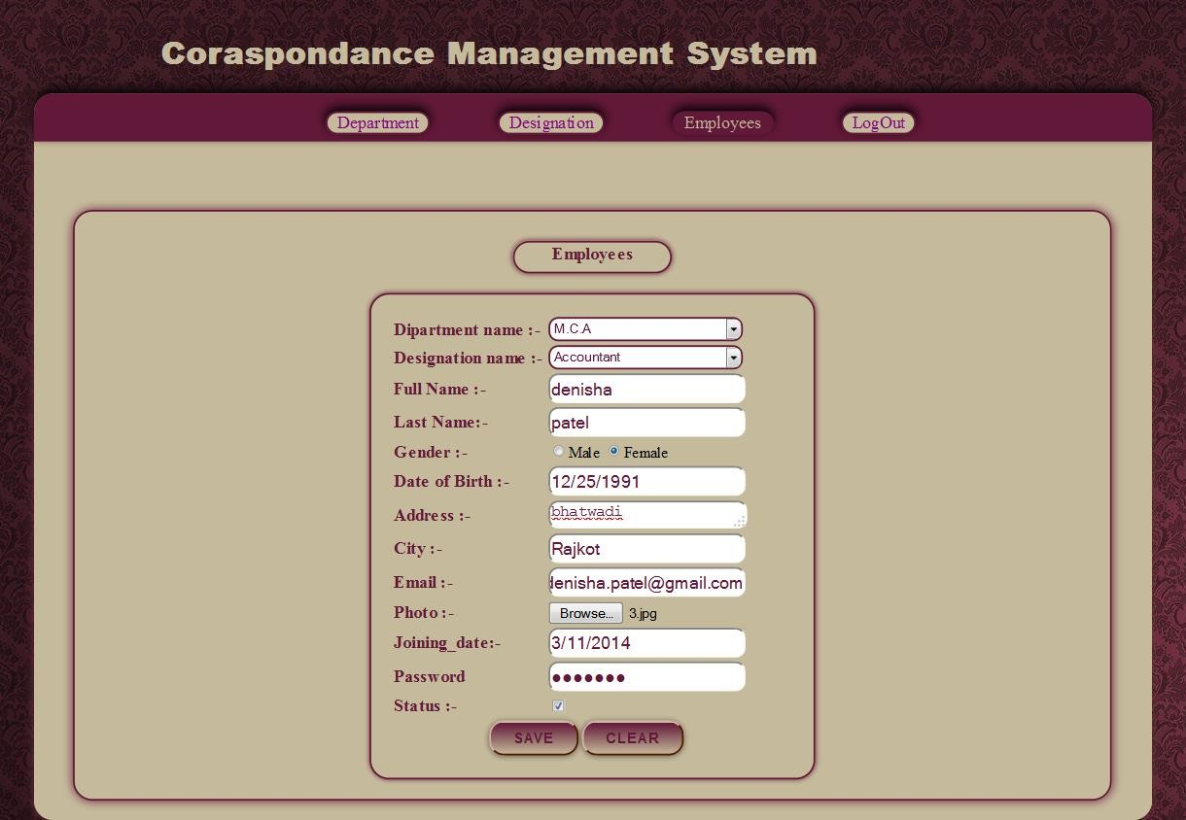

This page is used for add employee

CMS 2021

EMPLOYEE

HOMEPAGE:

This page is home page of employee side

CMS 2021

EMPLOYEE LOGIN:

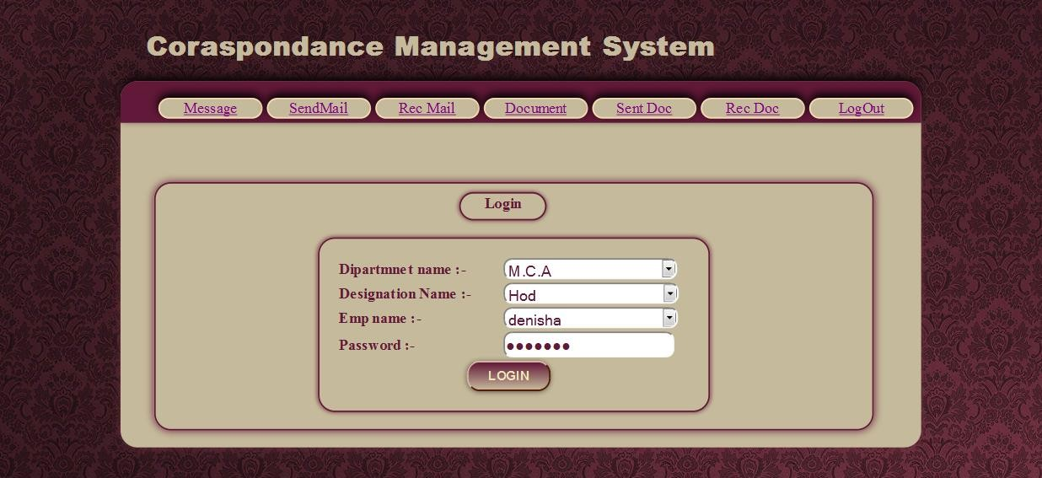

By using this employee can login

CMS 2021

MESSAGE:

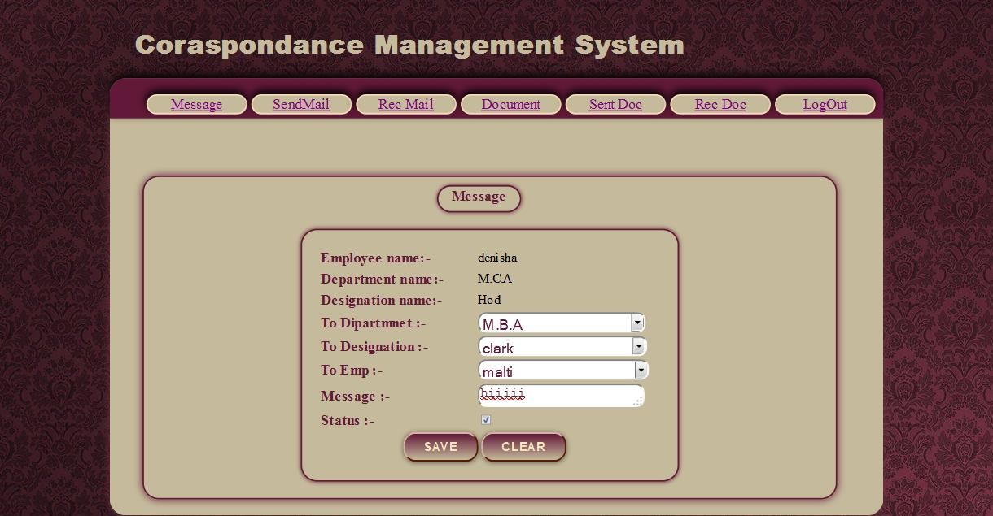

By using this employee can send mail

CMS 2021

SEND MAIL:

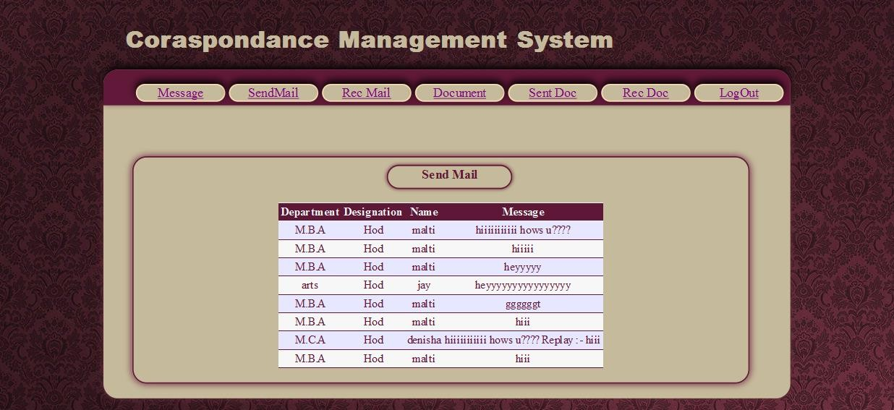
By this page employee can see the details of send mail

RECEIVE MAIL:
CMS
2021

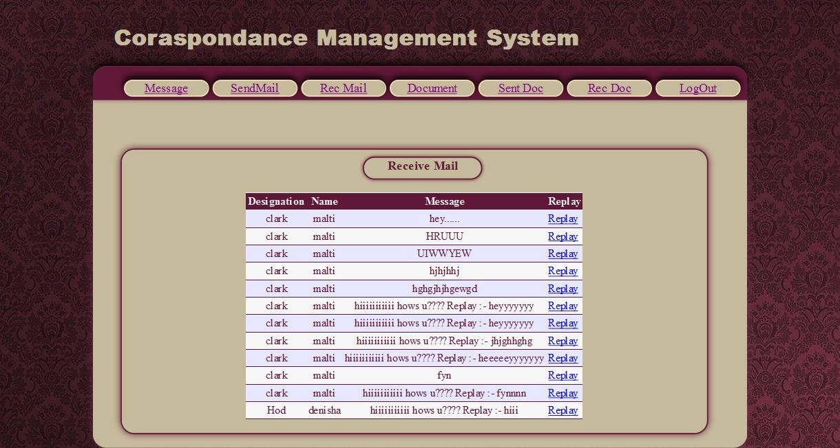

By this page employee can see the received mail and also replay the mail

DOCUMENT:
CMS
2021

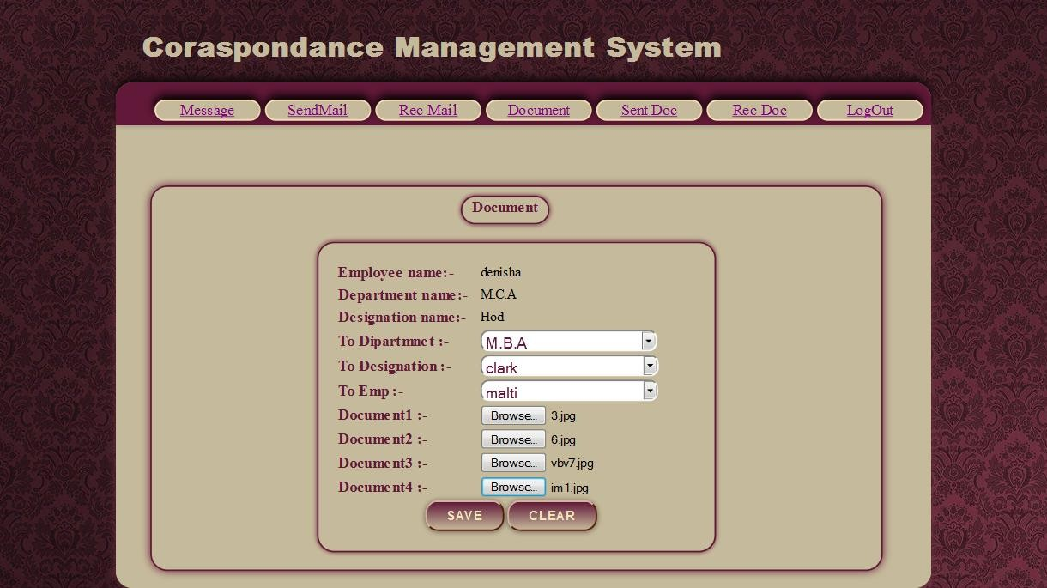

By this page employee can send documents

SEND DOCUMENT:
CMS
2021

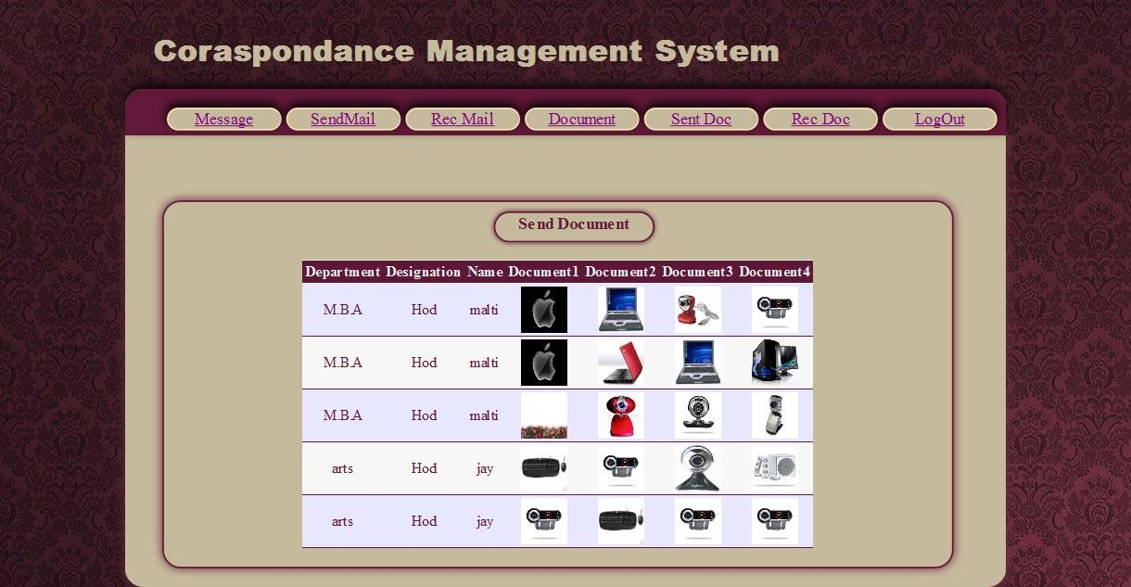

By this page employee can see the documents that he/she has send

CMS 2021

RECEIVE DOCUMENT:

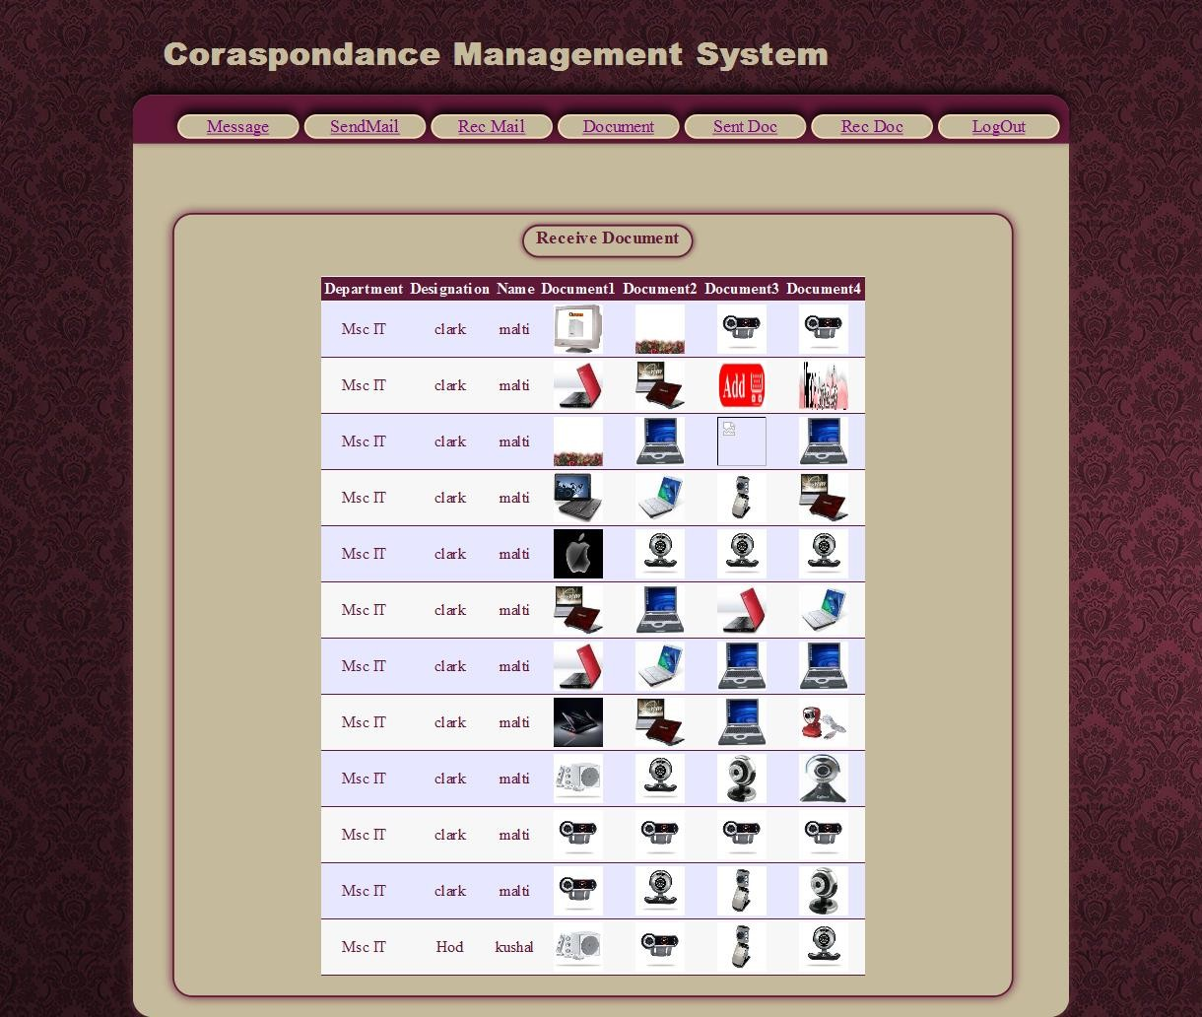

By this page employee can see the received document

CMS 2021

THANK YOU

